NAAN MUDHALVAN ASSIGNMENT

**NAME:** VIGNESH KANNA B S

**DEPARTMENT:** COMPUTER SCIENCE AND ENGINEERING

**COLLEGE:** DHANALAKSHMI SRINIVASAN INSTITUTE OF TECHNOLOGY

**NAAN MUDHALVAN COURSE:** DIGITAL MARKETING

**NM ID:** 8555D655B967DF59C4A4E565EDF4A826

**ASSINGMENT 1:**

Create a blog or website using blogspot and wordpress. Customize the theme design and post new article with 500 words

**URL:** <https://dolphinaqua7.blogspot.com/2023/08/dolphin-aquarium.html>

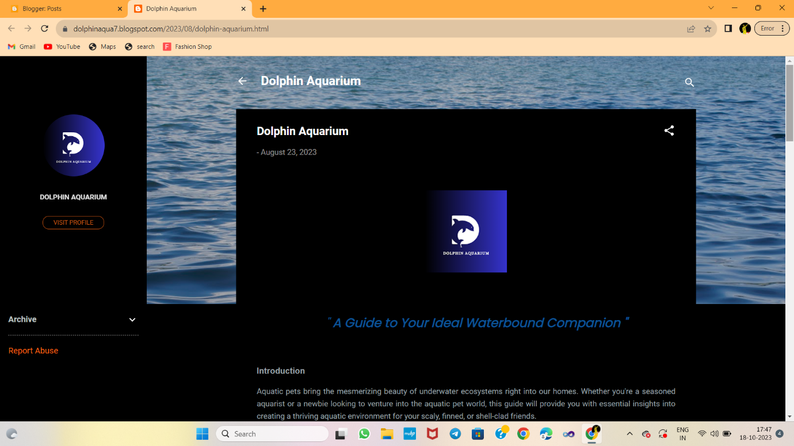

**ASSINGMENT 2:**

Create a new Facebook business page and post one social media poster for your brand.

**URL:** <https://www.facebook.com/dolphin.aqu?mibextid=9R9pXO>

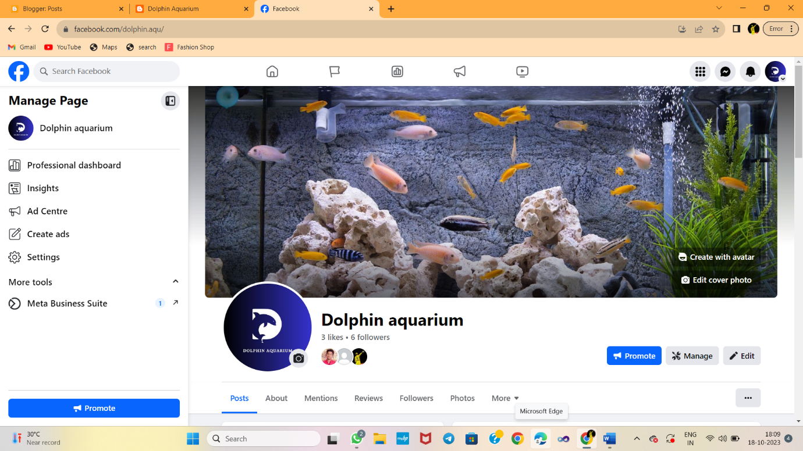

**ASSIGNMENT 3:**

Create and design a advertisement poster using canva.

**URL:** <https://www.facebook.com/photo/?fbid=122098119158021044&set=a.122098119488021044>

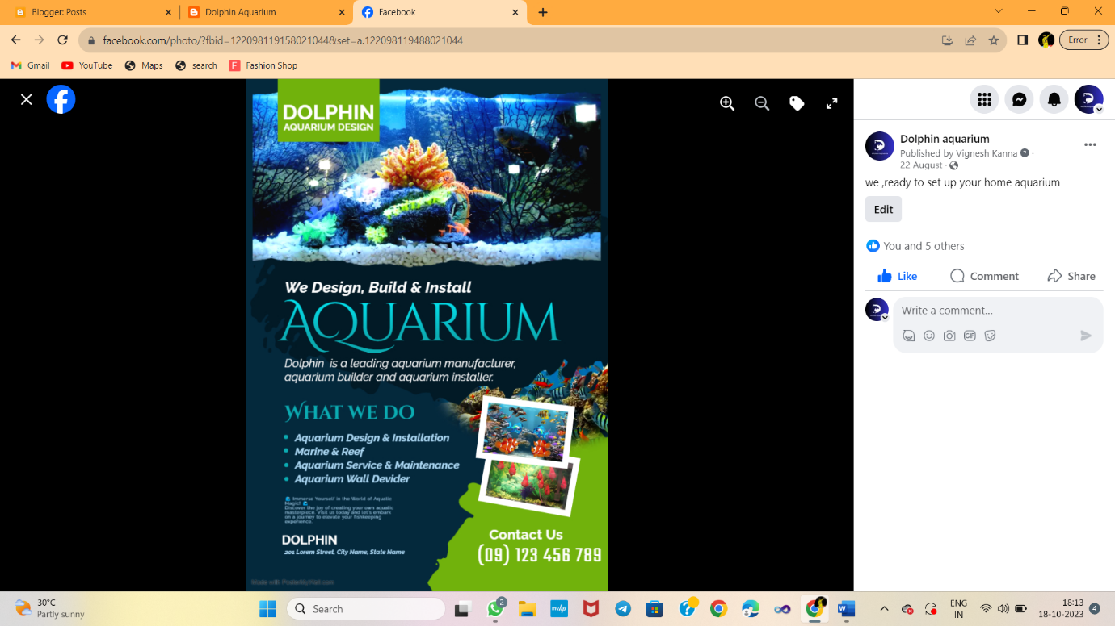

**ASSIGNMENT 4:**

Create an Email newsletter design using Mailchimp or Canva tool

**URL:** <https://dolphinaqua7.blogspot.com/2023/09/blog-post.html>

